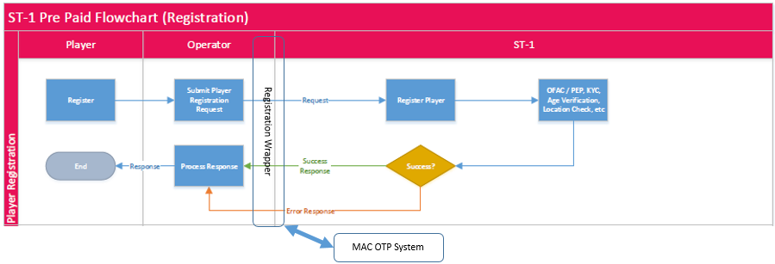

Wrapper Process (Happy path)

1. Catch Player Registration Request from Operator
2. Send request to ST-1
3. Wait for reply from ST-1
4. On reply, ‘Success”
5. Send Register to MAC OTP System
6. On Success, Send RequestOTP to MAC OTP System
7. Redirect player to Enter OTP Page on Player’s computer
8. Player enters OTP and clicks submit
9. Send Verify OTP to MAC OTP System
10. If validated close I-Frame on player’s machine
11. Send “Success” to operator

Wrapper Process (Error Response from ST-1)

1. Catch Player Registration Request from Operator
2. Send request to ST-1
3. Wait for reply from ST-1
4. On reply, If “Error Response”
5. Send “Error Response” to operator

Wrapper Process (Valid OTP)

1. Catch Player Registration Request from Operator
2. Send request to ST-1
3. Wait for reply from ST-1
4. If ST-1 reply ‘Success”
5. On reply, ‘Success”, Display Enter OTP I-Frame on Player’s computer
6. Send RequestOTP to MAC OTP System
7. Player enters OTP and clicks submit
8. Send Verify OTP to MAC OTP System
9. On OTP “validated”, close I-Frame on player’s machine
10. Send “Success” to operator

Wrapper Process (Invalid OTP,)

1. Catch Player Registration Request from Operator
2. Send request to ST-1
3. Wait for reply from ST-1
4. If ST-1 reply ‘Success”
5. On reply, ‘Success”, Display Enter OTP I-Frame on Player’s computer
6. Send RequestOTP to MAC OTP System
7. Player enters OTP and clicks submit
8. Send Verify OTP to MAC OTP System
9. On OTP “Invalid/Error”, update I-Frame with error
10. Player enters OTP and clicks submit
11. Send Verify OTP to MAC OTP System
12. On OTP “Invalid/Error”, update I-Frame with error
13. Player enters OTP and clicks submit
14. Send Verify OTP to MAC OTP System
15. On OTP “Validated”, Send “Success” to operator

Wrapper Process (Invalid OTP, Too many retries, time out)

1. Catch Player Registration Request from Operator
2. Send request to ST-1
3. Wait for reply from ST-1
4. If ST-1 reply ‘Success”
5. On reply, ‘Success”, Display Enter OTP I-Frame on Player’s computer
6. Send RequestOTP to MAC OTP System
7. Player enters OTP and clicks submit
8. Send Verify OTP to MAC OTP System
9. On OTP “Invalid/Error”, update I-Frame with error
10. Player enters OTP and clicks submit
11. Send Verify OTP to MAC OTP System
12. On OTP “Invalid/Error too many retries or Timeout”, update I-Frame with error and Close button
13. Send Delete player request to ST-1
14. On reply, send “error” to operator

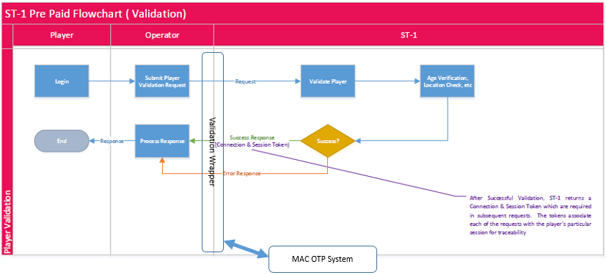

Wrapper Process (Happy path)

1. Catch Player Verification Request from Operator
2. Send request to ST-1
3. Wait for reply from ST-1
4. If ST-1 reply ‘Success”
5. Send RequestOTP to MAC OTP System
6. Display Enter OTP I-Frame on Player’s computer
7. Player enters OTP and clicks submit
8. Send Verify OTP to MAC OTP System
9. If validated close I-Frame on player’s machine
10. Send “Success” to operator

Wrapper Process (Error Response from ST-1)

1. Catch Request form Operator
2. Send request to ST-1
3. Wait for reply from ST-1
4. If ST-1 reply “Error Response”
5. Send “Error Response” to operator

